Monster Maintenance Utility
Purpose: The purpose of this utility is to clear old jobs left behind in the shared folder and to clear the interface of old jobs still listed in the queue.
Steps:
- Click on the administrator button. 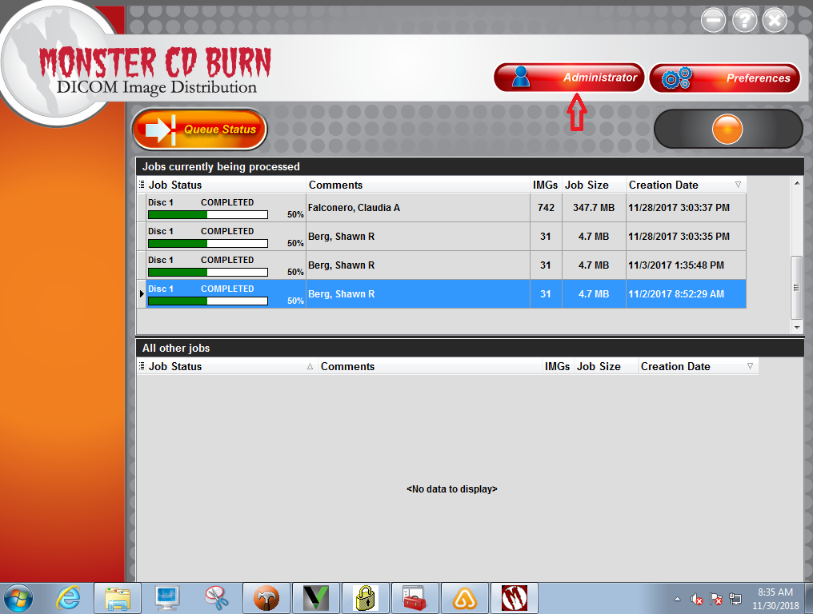
- Click on the Rimage Setup button.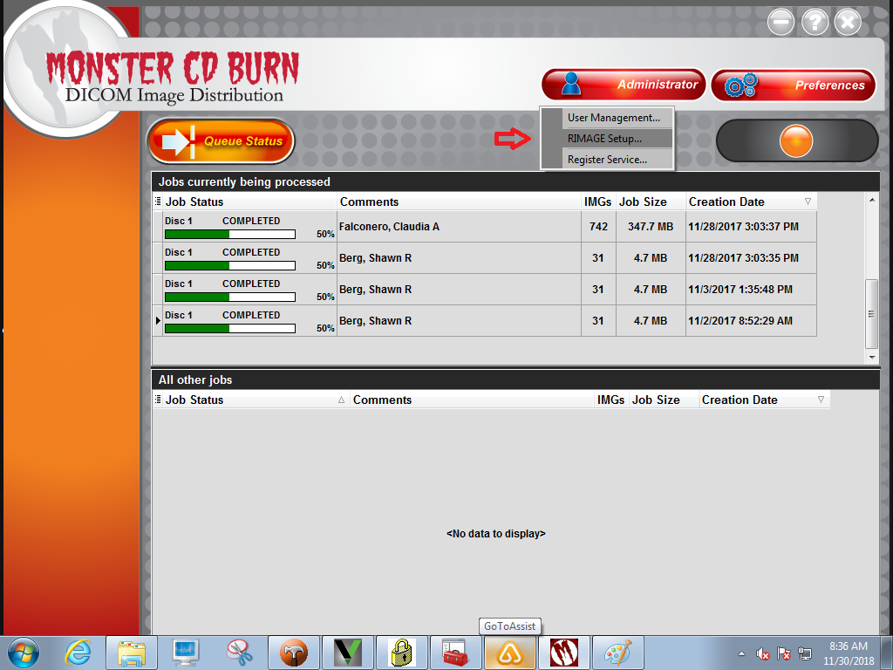
- Click the Stop button.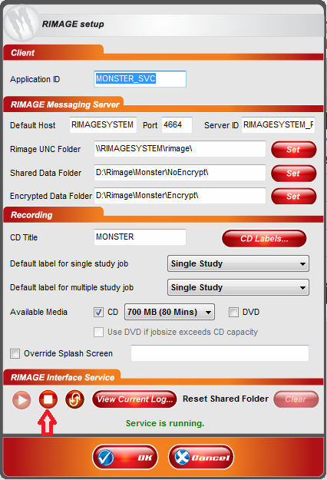
- Click the Clear button. 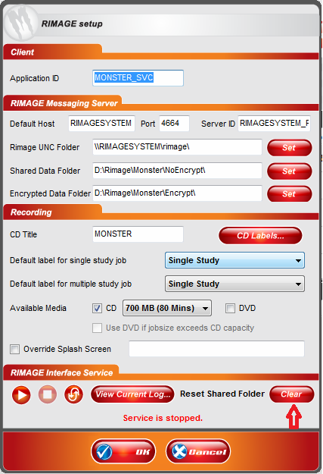
- Click the OK button.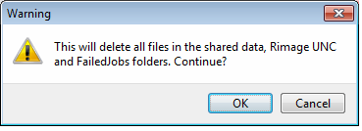
- Click the OK button 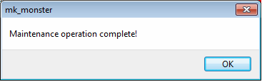
- Click the Start button.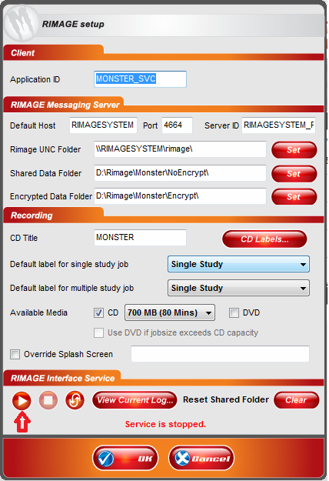
- Click the OK button.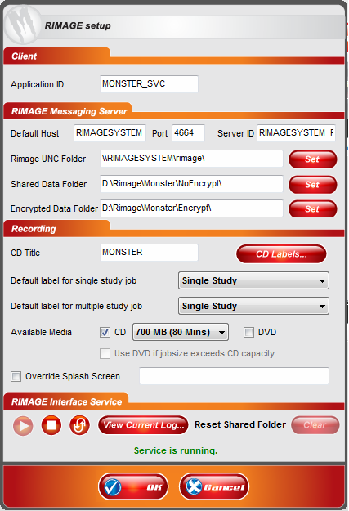
- Job queue is now cleared.