Client Install Guide

Crystal Reports
- Double click on CRReddist2008_x86
- Crystal Reports will install automatically
Rimage SDK
- Double click on Setup.exe
- 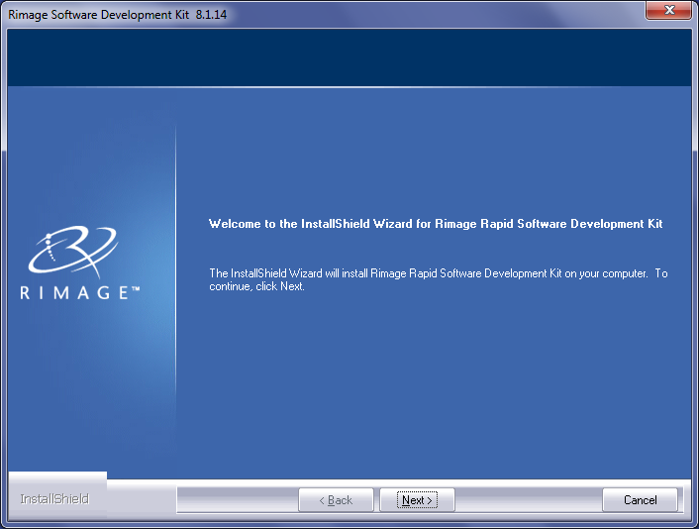
  - Click Next
- 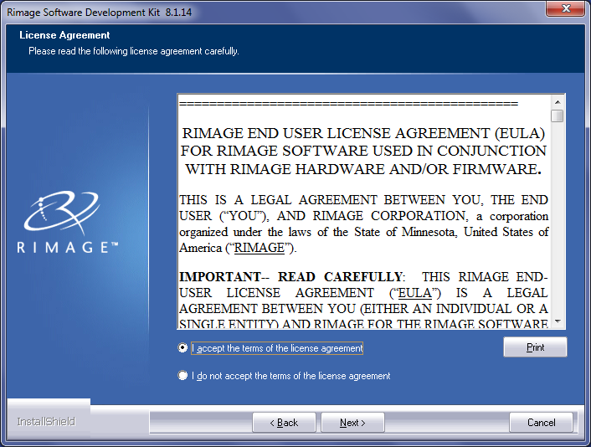
  - Accept Agreement
  - Click Next
- 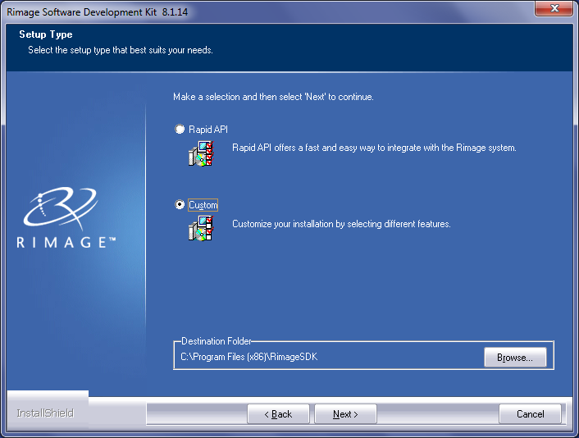
  - Click Custom
  - Take default path
  - Click Next
- 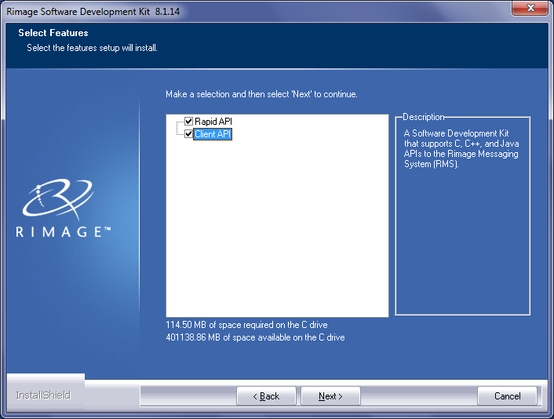
  - Check Client API
  - Click Next
- 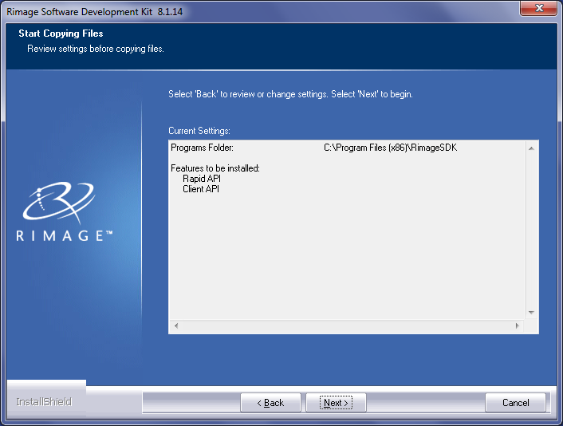
  - Click Next
- 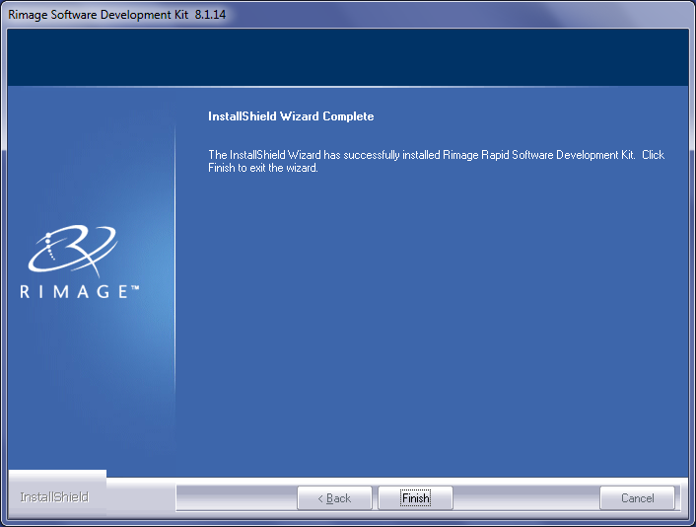
  - Click Finish
  - Close any Rimage API pop-up windows

DISCO JPS
DotNet 3.5 is required
- Double click on DiscoJPS.msi
- 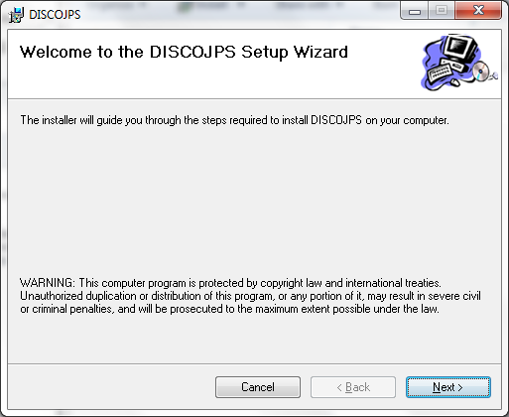
  - Click Next
- 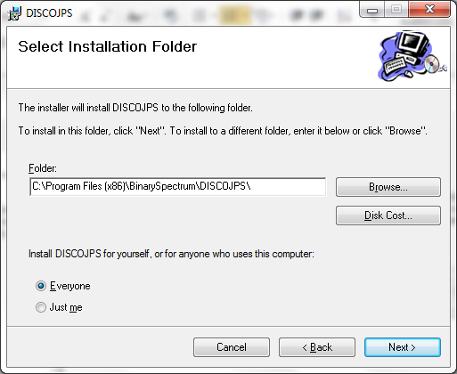
  - Click Next

- 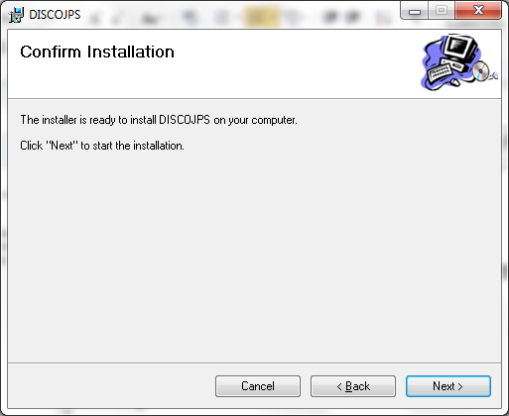
  - Click Next

- 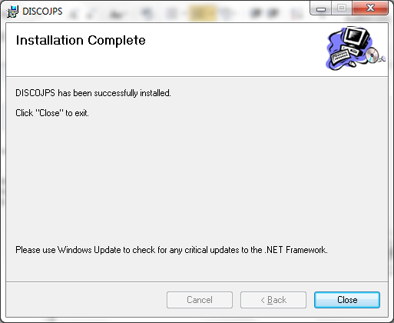
  - Click Close
- On the install disc, make a copy JobProcessing.exe.config.
- Copy the file to C:\Program Files (x86)\BinarySpectrum\DiscoJPS\
- Click Yes to overwrite
- On the install disc, make a copy of Print_Image.png.
- Copy the file to C:\Program Files (x86)\BinarySpectrum\DiscoJPS\BinaryStartUp\Images\
- Delete DISCOJPS icon from desktop
- On the install disc, make a copy of the Disco JPS shortcut
- Copy the file to C:\Users\Public\Public Desktop\
- Give Read/Write/Modify access to all or specific users on folder C:\Program Files (x86)\BinarySpectrum\DISCOJPS

